Curbside Electric Charging Station Application (Working Draft)

Table of Contents
Introduction 2
Important Considerations 4
Getting Started 5
Steps in the Process 5
Step 1: Application 5
Step 2: Permit Application Process 5
Placement and Design- Electric Vehicle Charging Station 8
Placement and Design- Receptacle only 9
Step 3: Installation 11
Step 4: Operation 11
Attachments 11
Terms and Definitions 11

Introduction
[Insert discussion of localities environmental goals, EVI Pro Tool Lite calculations, and discussion of fees and accessibility here]
In order to reach [environmental goal here], home charging is a priority for the [locality]. Reviewing deployment needs for electric vehicle charging using the EVI Pro Tool Lite from the U.S. Department of Energy, home curbside electric vehicle charging could reduce the need for [hundreds/thousands] of public chargers. This planning scenario below shows the difference between a 10% regional market for electric vehicles that can in large charge at home, and the same number of vehicles but with only 50% charging at home. It should be worth noting that census data indicates only 40% of Virginians have access to electricity within 20 feet of where they park. This limited access to electricity within charging distance means practices will need to be put in place to expand accessibility such as curbside charging. If folks don’t charge at home, far more public charging will be needed in [Locality] area.
In an ideal world, all individuals would have electric vehicle charging available at their homes, but this is not the reality. Below, two scenarios are outlined.
100% charging at home | 50% charging at home
# Workplace Level 2 Charging Plugs | # Workplace Level 2 Charging Plugs
# Public Level 2 Charging Plugs | # Public Level 2 Charging Plugs
# Public DC Fast Charging Plugs | # Public DC Fast Charging Plugs

[Locality] Region EV Charging Model EVI Pro Lite – 10% EV/PHEV ownership
[Insert map here] | Vehicle Mix to meet 10% Goal
(Number of EV to support [2016 number of vehicles on the road *.1] =10%)
Plug-in Hybrids 20-mile electric range #%
Plug-in Hybrids 50-mile electric range #%
All-Electric Vehicles 100-mile electric range #%
All-Electric Vehicles 250-mile electric range #%
Most PHEV drivers wouldn’t need to use gasoline on a typical day.
 | Vehicle Mix as of 2016
Plug-in Electric Vehicles: #
Light Duty Vehicles: #

L2: There are currently # plugs with an average of # plugs per charging station and; DCFC: There are currently # plugs with an average of # plugs per charging station per the Department of Energy’s Alternative Fuels Data Center Station Locator.

Accessibility
In pilots of EV curbside charging deployments, such as the Berkley Residential Curbside Electrical Vehicle (EV) Charging Pilot Program, high costs have been shown as a major barrier to adoption. In Berkley’s case, installations often ranged from $5,000 to $20,000. These costs were in part due to a program preference to cut new driveways rather than installing curbside chargers, but these high costs were also due to high planning and permitting fees from the city of Berkeley which typically amounted to $2,500.
At this time, [ description of localities current electrical and minor encroachment fees and accessibility] Excessive fees limit accessibility and overcomplicate what should be a simple installation process. Keeping fees accessible can greatly reduce the costs of these projects and thus extend accessibility to a wider range of households. This is especially applicable when one of the majors draws to EVs is the lower fueling costs compared to their gasoline counterparts. It is suggested that the [Locality] instate a minor encroachment permitting process for the purposes of residential curbside electric vehicle charging stations. This process, (application attached) should have fees equating to no more than $100 per application. The cost of level 2 charging units typically ranges from $600 to $2,000. With permitting equating to roughly $200 per project, it is expected that the cost of a curbside installation in total could cost closer to $1,000-$5,000 per installation including permitting, equipment, labor, and any electrical upgrades needed.

Electrical Permit | [description of fee]
Minor Encroachment Permit | [description of fee]

Curbside charging not only supports the [Locality] goals of [environmental goals here] by providing access to chargers, it also visibly demonstrates that EVs are the future.

Important Considerations
Driving an EV rather than a conventional car offers a range of potential benefits including reduced maintenance and fueling costs, Federal and State incentives, and energy security. Before considering leasing or buying an EV, it is also critical to consider how and where you will charge the vehicle. You may be able to charge at your workplace or use public charging stations, mapped on sites such as plugshare.com or the U.S. DOE Alternative Fueling Station Locator, but most EV drivers charge at home.
This manual describes opportunities for charging an EV at homes that desire curbside charging. When starting to evaluate whether curbside charging is appropriate for you, it is important to understand what is involved. Here are some quick tips:
Talk with a licensed electrical contractor early in the process. Level 2 charging stations appropriate for residential outdoor installations are currently priced at $600 to $2,000 or more, but the installation costs may be greater, particularly if long conduit runs, extensive trenching, or electrical upgrades to your home are required.

Call Before you dig. As you plan and permit your EV charging station or receptacle it is important to consider what infrastructure may already exist underground on your property and into the right of way. As you make your site plans, please contact your utilities and VA811 to ensure that your trenching will not disturb any pre-existing infrastructure.

Installation of a curbside charging station will not give you special rights or privileges to the street parking adjacent to the station. Street parking will remain available to anyone. Any parking restrictions on your street, such as Residential Preferential Parking, will remain in effect. Additionally, the installation of an EV charging station or receptacle will not authorize parking where parking was not previously permitted.

Charging stations must be listed (i.e. UL) and certified for outdoor use. Most individuals installing curbside chargers will install Level 2 charging stations utilizing 240-volt AC power. Level 1 charging stations, using 120-volt AC power, with appropriate safety and enclosure specifications may also be used.

Getting Started
The opportunity is open to all types of residences (single-family, duplex, multifamily buildings, etc.). If you rent your home, you will need to coordinate with your landlord to participate; permits will be issued to the property owner.

Steps in the Process
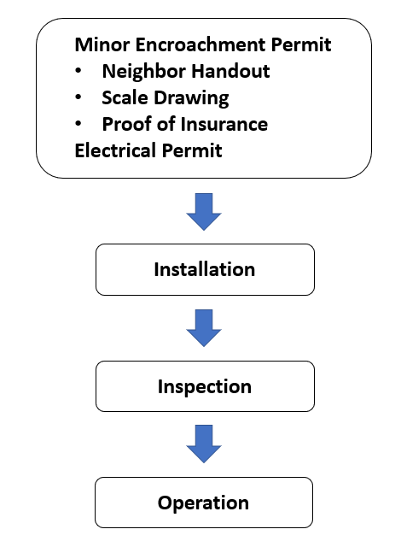

Step 1: Application
Fill out the EV Curbside application form and submit for city approval.

Step 2: Permit Application Process
Once your application has been approved, complete the neighborhood handout, minor encroachment, and electrical permitting process. If you haven’t already, contact a licensed electrical contractor to verify that your home electrical system can meet your charging needs. Make sure that you understand your likely equipment and installation costs and that your contractor understands the permitting process.

Purchase
Once your application is approved, purchase your unit. For all curbside charging installations residents are advised to purchase a Level 1 (120-volt) or Level 2 (240-volt) charging unit that is able to be installed on a dedicated circuit extending from the residence. When selecting a unit, especially those at higher voltage, it is recommended that the resident communicates with their utility provider to determine if their existing electrical system has the capacity to support the charger or if additional capacity will be needed.

Permit Application Submittals
The installation of a curbside EV charging station requires a minor encroachment permit and an electrical permit to install the EV charging station.

Minor encroachment permit applications require, at a minimum:
1. Minor Encroachment Permit Application
2. Distribution of the Neighbor Handout to all dwelling units on the block (both sides of street)
3. Scaled drawing with the dimensions of the encroachment
4. Proof of insurance

Neighborhood Handout
It is your responsibility to share information about your project with neighbors before submitting your minor encroachment permit application so that they have an opportunity to ask questions and understand the process. You must review, complete, and distribute the Neighbor Handout to all households on the block (both sides of the street) where the charging station is proposed prior to applying for a permit.

Please understand your responsibilities and limitations before talking to your neighbors. The cost of purchasing, installing, using, and maintaining a curbside EV charging station are all paid by the homeowner (or in combination with a tenant, if applicable). It is the responsibility of the property owner to maintain the charging station, and any associated safety enclosure, in good, safe repair. The property owner must be the minor encroachment permit applicant.

As part of the minor encroachment permit process, notices about the proposed EV charging station will be posted on your block by the City. This will allow neighbors a formal opportunity to make comments on the project.

A minor encroachment permit is revocable. The City may take action to revoke the permit in cases such as safety concerns related to the EV charging station or on-going parking issues adjacent to the EV charging station that result in enforcement calls to the City. If the minor encroachment permit is revoked, it will be the property owner’s responsibility to remove the EV charging station and its associated equipment, conduit, and wiring from the public right-of-way and restore the right-of-way to its original condition.

There is a two-week posting period for minor encroachment permit applications. During this posting period, the public has the opportunity to submit questions, comments, and objections to the proposed encroachment. The City’s department of permits and inspections will consider all responses when making the decision to deny or approve the minor encroachment permit. The minor encroachment permit will include conditions for installation, maintenance, and provisions for removal. Conditions will also include requirements to indemnify the City for any harm arising out of installation, use, or misuse of the EV charging station.

Important: The parking space that is adjacent to a curbside EV charging station is available to anyone. Any parking restrictions on your street, such as Residential Preferential Parking, will remain in effect. You will not have any exclusive rights, privileges, or priority for parking adjacent to an EV charging station and should not state or imply such. A sign/sticker will also be posted on the curbside EV charging station clarifying that it is a private installation, but that the parking space is available to the public. If you know that it is difficult to park adjacent to your home or you foresee issues that would limit your access a curbside EV charging station on a regular basis, please consider whether it makes sense for you to install a curbside charger.

Electrical permit application and submittals include:
1. Permit Application
2. Site plan with property lines, proposed vehicle-related paving and EV charging station location, conduit routing, and location of electrical service
3. Existing electrical service size and number of meters; size, type, and material of conductors, associated wiring components, and conduit; single line diagram
4. Feeder or service load calculations for EV charging stations requiring more than a 40 amp overcurrent protective device
5. Manufacturer’s specifications and installation guidelines for the EV charging station including the approved product listing agency (i.e. UL) number

Important: Construction must comply with all applicable local regulations, including the City of [Locality] Zoning Ordinance and Municipal Code, which includes the 2014 National Electrical Code.

Estimated Fees
Permitting fees are minimized by submitting complete, clear documentation. The fees indicated here represent estimated minimum permitting costs for construction installation of a new residential curbside EV charging unit.

Electrical Permit | [description of fee]
Minor Encroachment Permit | [description of fee]

Curbside Charging
The minor encroachment permit process will be used to permit residential curbside charging stations. Encroachment permits, applicable to structures built in the public right-of-way, are only issued in very limited situations.

The EV charging station or receptacle will be connected to your home electrical service, as it would be if it was located on your private property. Conduit will be run from your electrical panel to the EV charging station located in the planting strip adjacent to the curb. The conduit must be underground in the public right-of-way, including under the sidewalk, and it is likely that trenching will also be required on your private property.

Important: Conduit for the EV charging station must be routed directly from the curbside EV station to the property line, perpendicular to and under the sidewalk. Conduit within the public right of way must be minimized and must not be routed parallel to the sidewalk or curb within the planting strip or on public land behind the sidewalk.

Please work with a licensed electrical contractor to understand your options; all installations must be performed by a licensed contractor.

Curbside EV charging station installations may be either Level 1 (120-volt) or Level 2 (240-volt), but must meet all the requirements of the 2014 National Electrical Code as adopted by the Commonwealth of Virginia. All Electrical Vehicle Supply Equipment (EVSE) must adhere to the requirements outlined in the article 625 of the 2014 National Electrical Code which specifies that installations of electric vehicle supply equipment (EV charging stations) must be permanently connected and fastened in place with no exposed live parts. Charging stations must also be rated for outdoor use, and installed in accordance with the manufacturer’s specifications.

Curbside EV Charging Station Use
The City anticipates that residential curbside EV charging stations or receptacles will be installed for personal use. Use of the charging station or receptacle will be controlled either by a safety enclosure around the charging station or cord that is locked while the station is idle or by a power disconnect switch located near the electrical panel, or a combination.

If you wish to make a residential curbside EV charging station open to the public, its placement and location must be accessible (ADA compliant) and available, free of charge, at all times. If this is of interest, please let us know early in your application process so that we can work with you on creating an accessible design.

Placement and Design- Electric Vehicle Charging Station
As you work with a licensed contractor to develop plans for the installation of a curbside EV charging station, follow these guidelines:

Work conducted in the public right-of-way must adhere with the materials, designs, and construction methods detailed by the City.

Placement:
- Position the EV charging station such that the stored connector is at a minimum height of # inches above grade level ([Insert locally adopted code])
- Avoid conflicts with other utility infrastructure
- At least 6 feet from street trees, fire hydrants, and utility poles [Replace with local requirement if applicable]
- At least 18” from the face of the curb or start of street if no curb is present [Replace with local requirement if applicable]
- Minimum unit height of 41” for curbside visibility [Replace with local requirement if applicable]
- Avoid interference with vehicular sight lines at street corners or driveways
- Minimize the removal of vegetation
- Maximize the number of parking spaces it could serve
- EV charging station cords may not cross sidewalks, walkways, or driveways
- Preserve as much sidewalk width (path of travel) as possible, but no less than 5 feet
- Placement will not authorize cars to park cars backwards
- To charge, the vehicle must park in line with the charging unit
- EV charging station may only be placed where parking is previously permitted
- The installation of a charging unit will not authorize parking where parking is not already authorized

Design:
- Power-supply cord (electric vehicle charging unit to power receptacle) length cannot surpass the maximum 1.8 m (6 ft) (2014 National Electrical Code, Article 625.44B3)
- The overall useable cord and cable length (charging unit to vehicle) shall not exceed 7.5 m (25 ft) unless equipped with a cable management system that is part of the listed electric vehicle supply equipment. Where the EVSE is fastened in place as a stationary unit, the useable length of the output cable shall be measured from the cable exit of the electric vehicle supply equipment or charging system to the face of the electric vehicle connector. (2014 National Electrical Code, Article 625.17 C and C2)
- Receptacles must be located to avoid physical damage to the flexible cord (2014 National Electrical Code, Article 625.44B4)
- Consider an enclosure or cage around the EV charging station to protect and control its use; if the charging station is not fully enclosed, the charging station cord and connector must be secured when not in use
- Orient the EV charging station such that an enclosure door will not open past the curb face or over the sidewalk
- Minimize the size of any enclosure around a charging station or cord
- Colors and materials for any enclosure should minimize their visibility and integrate with the design of surrounding buildings and landscaping
- No advertising is permitted on the charging station or associated enclosure
- The [Locality] is permitted to place stickers on the unit
- Level 1 (120-volt) or Level 2(240-volt) up to 19.2 KW chargers on a dedicated circuit from the house, no DC Fast chargers are allowed
- Smaller units are preferred
- Small, lockable box design that aligns with neutral, environmental or neighborhood color scheme

Placement and Design- Receptacle only
Work conducted in the public right-of-way must adhere with the materials, designs, and construction methods detailed by the City. As you work with a licensed contractor to develop plans for the installation of an electrical receptacle, follow these guidelines:

Placement:
- Position the unit such that the receptacle is at a minimum height of 24 inches above grade level (2014 National Electrical Code, Article 625.50)
- Avoid conflicts with other utility infrastructure
- At least 6 feet from street trees, fire hydrants, and utility poles
- At least 18” from the face of the curb or start of street if no curb is present [Replace with local requirement if applicable]
- Minimum unit height of 41” for curbside visibility [Replace with local requirement if applicable]
- Avoid interference with vehicular sight lines at street corners or driveways
- Minimize the removal of vegetation
- Maximize the number of parking spaces it could serve
- Cords may not cross sidewalks, walkways, or driveways
- Preserve as much sidewalk width (path of travel) as possible, but no less than 5 feet
- Placement will not authorize cars to park cars backwards
- To charge, the vehicle must park in line with the receptacle
- Receptacle may only be placed where parking is previously permitted
- The installation of a receptacle will not authorize parking where parking is not already authorized

Design:
- All outdoor receptacles must adhere to the codes outlined in the 2014 National Electrical Code, please work with a licensed electrical contractor
- Receptacles must be located to avoid physical damage to the flexible cord (2014 National Electrical Code, Article 625.44B4)
- Consider an enclosure or cage around the EV charging station to protect and control its use; if the charging station is not fully enclosed, the charging station cord and connector must be secured when not in use
- Orient the receptacle such that an enclosure door will not open past the curb face or over the sidewalk
- Minimize the size of any enclosure around a charging station or cord
- Colors and materials for any enclosure should minimize their visibility and integrate with the design of surrounding buildings and landscaping
- No advertising is permitted on the charging station or associated enclosure
- The [Locality] is permitted to place stickers on the unit
- Receptacle should be wired to service a Level 1 (120-volt) or Level 2(240-volt) up to 19.2 KW chargers on a dedicated circuit from the house, no DC Fast chargers
- Small, lockable box design that aligns with neutral, environmental or neighborhood color scheme

Electric Vehicle Supply Equipment:
- Power-supply cord (electric vehicle charging unit to power receptacle) length cannot surpass the maximum 1.8 m (6 ft) (2014 National Electrical Code, Article 625.44B3)
- The overall useable cord and cable length (charging unit to vehicle) shall not exceed 7.5 m (25 ft) unless equipped with a cable management system that is part of a listed the electric vehicle supply equipment. When not fastened in place, such as when plugged into a receptacle, the cord exposed useable length shall be measured from the face of the attachment plug to the face of the electric vehicle connector. (2014 National Electrical Code, Article 625.17C and C1)
- Ensure proper hard-wiring, or that the NEMA receptacle and plugs on your Electric Vehicle Supply Equipment and the receptacle are compatible or that your charging unit has compatible adapters.

Potential aesthetic design options
- 10-inch diameter bollard that could lift up to hide the charger
- Fake utility hiding fiberglass “rock”
- Integrated into mailbox design
- Integrated into a little library design

Step 3: Installation
Once you have obtained permit approvals for curbside EV charging station, you are ready to install the station and any corresponding features. [Locality’s] inspection staff will inspect the EV charging station. Once your inspections are final, you are ready to charge!

Step 4: Operation
It is your responsibility to operate your EV charging station in keeping with the conditions of its permits. It must be operated in a way that minimizes potential trip hazards associated with the cord including safely storing the cord and connector while not actively being used for EV charging. Failing to keep up with these obligations could result in the City revoking your minor encroachment permit for the EV charging station and require removal by the homeowner.

Attachments
The following specialized forms, are available on the [locality’s] website and are also attached to this Manual:
- Minor Encroachment Permit Application
- Neighbor Handout
- Electrical Permit Application

Terms and Definitions

Cable Management System (electric vehicle supply equipment): An apparatus designed to control and organize unused lengths of output cable to the electric vehicle (NEC 2014).

Electric Vehicle Connector: A device that, when electrically coupled (conductive or inductive) on an electric vehicle inlet, established and electrical connect to the electric vehicle for the purpose of power transfer and information exchange. This device is part of the electric vehicle coupler (NEC 2014).

Electric Vehicle Coupler: A mating electric vehicle inlet and electric vehicle connector set (NEC 2014).

Electric Vehicle Inlet: The device on the electric vehicle into which the electric vehicle connector is electrically coupled (conductive or inductive) for power transfer and information exchange. This device is part of the electric vehicle coupler. For the purposes of this code, the electric vehicle inlet is considered to be part of the electric vehicle and nor part of the electric vehicle supply equipment. Informational note: for further information, see 635.48 for interactive systems (NEC 2014).

Electric Vehicle Supply Equipment: The conductors, including the ungrounded, grounded and equipment grounding conductors, and the electric vehicle connectors, attachment plugs, and all the other fittings, devices, power outlets, or apparatus installed specifically for the purpose of transferring energy between the premises wiring and the electric vehicles (NEC 2014).

Charger Type | Alternating or Direct Current | Amperage | Voltage | Power | Range per Hour of Charging
Level 1 | Alternating (AC) | 12-16 Amps | 120 Volts | 1.3-1.9 kW | 2-5 miles
Level 2 | Alternating (AC) | Up to 80 Amps | 208-240 Volts | Up to 19.2 kW | 10-20 miles

Level 1 Chargers: L1 chargers use an alternating current and are used primary for residential or workplace charging due to their long charge times. Nearly every (PEV) comes with a traditional three-pronged plug for an outlet with a J1772 standard connector plug for insertion into the vehicle.

Level 2 Chargers: L2 chargers also use an alternating current, but at a higher amperage and voltage, resulting in a decent improvement in charge time. L2 chargers can be used for residential and workplace charging but require a larger investment in infrastructure. L2 chargers cannot be connected into a traditional wall outlet and must have hard-wired charging equipment. L2 chargers have become commonplace for public charging and also use a J1772 connector plug. See below image of J1772 connector plug.

Output cable to the electric vehicle. An assembly consisting of a length of flexible EV cable and an electric vehicle connector (supplying power to the electric vehicle) (NEC 2014).

Personal Protection System: A system of personnel protection devices and constructional features that when used together provide protection against electric shock of personnel (NEC 2014).

Power-supply cord. An assembly consisting of an attachment plug and length of flexible cord that connects the electric vehicle supply equipment (EVSE) to a receptacle (NEC 2014).

Power Outlet: An enclosed assembly that may include receptacles, circuit breakers, fuse holders, fused switches, buses, and what-hour meter mounting means; intended to supply and control power to mobile homes, recreational vehicles, park trailers, or boats or to serve as a means for distributing power required to operate mobile or temporarily installed equipment (NEC 2014).

Receptacle: a receptacle is a contact device installed at the outlet for the connection of an attachment plug. A single receptacle is a single contact device with no other contact device on the same yoke. A multiple receptacle is two or more contact devices on the same yoke (NEC 2014).

NEMA Configurations- receptacles and plugs. NEMA stands for the National Electrical Manufactures Association who have established standards for receptacles and plugs. Different receptacle and plug configurations correlate with different voltage and amperages. Different charging units and brands use different configurations, see below for examples of different NEMA configurations.

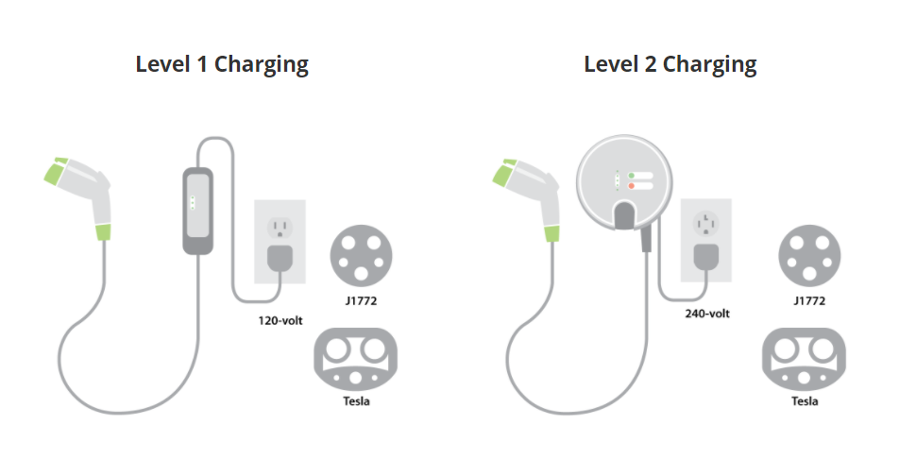
Figure 1 Image from the Central California Asthma Collaborative
Additional examples of Level 2 charger NEMA configurations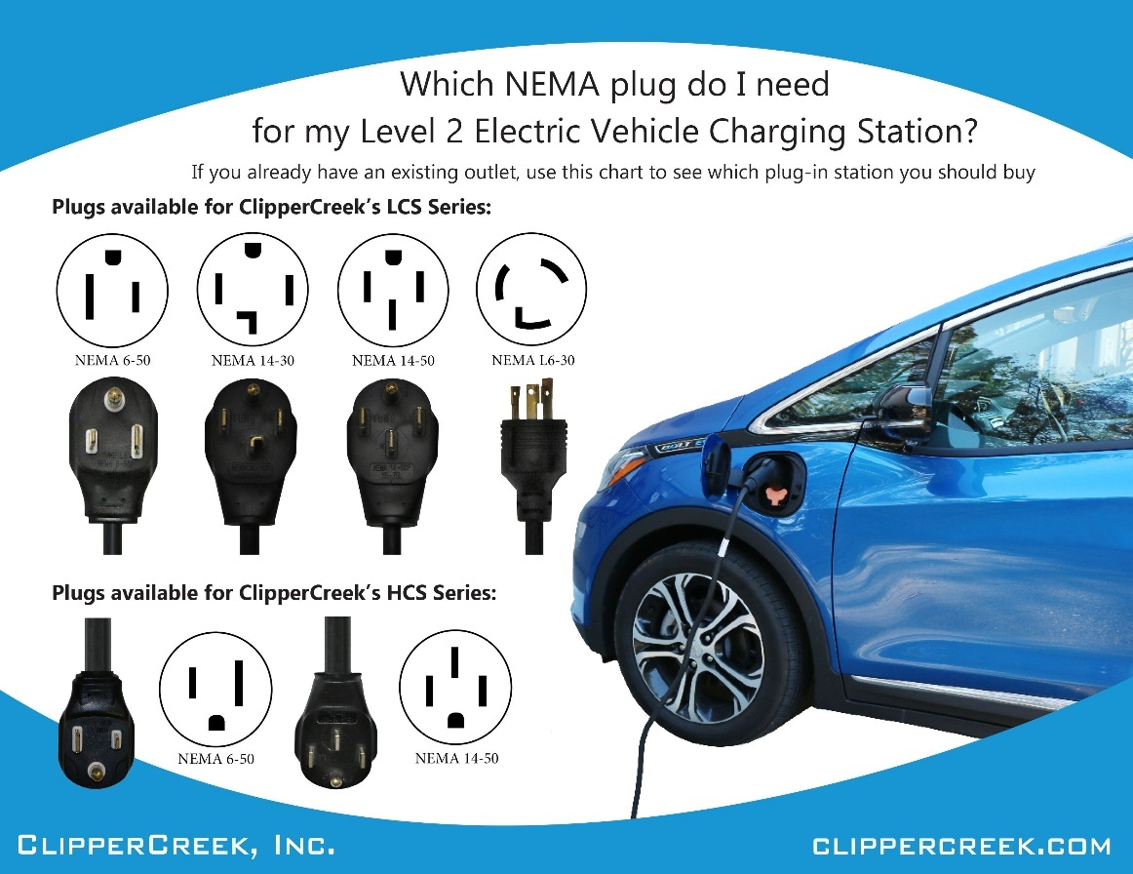
Figure 2 Examples of NEMA plugs used by Clipper Creek Level 2 charging stations
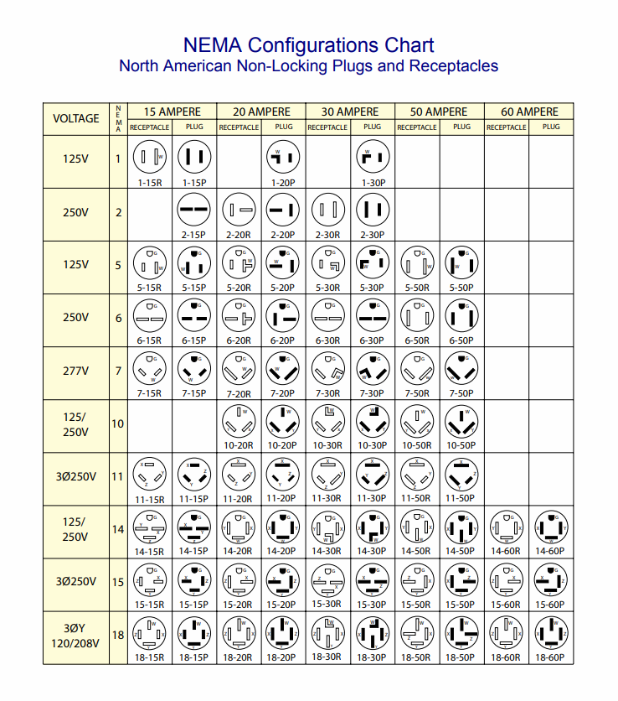
Figure 3 NEMA configurations by Voltage from americord.com

